A000-Asia-Pakistan-Indus Seals-ca. 2800-1900 BCE

**2. PK119.5, nos. 1 -8**

**3.** Asia-Pakistan-Indus Seals

**4. Images:**

**5. Dimensions:**

**5.1 H[eight]: W[idth]: L[ength]:**

**5.2 Weight :**

**6.1 Description-General:** These seals contain an undeciphered, indigenous script that initially was developed during the Kot Diji Phase (2800-2600 BCE) along with the standardization of weights both of which are linked to the emergence of initial urbanization in the Indus region and a more highly differentiated society (Meadow and Kenoyer 2001). Long distance trade that became increasingly important during Kot Diji Phase and the following Harappa Phase (2600-1900 BCE) which is suggested by the image on seal **PK119.5, no. 6** of a double-prowed ship that could have been used between the trading centers on the Lothal peninsula and the Persian Gulf islands and the gulf coast Sumerian cities of Ur, Uruk and Lagash ca. 2800-2600 BCE.

**6.2 Description-Specific of each item**

**PK119.5, no. 1.** Terracotta Terracotta stamp seal with a rhinoceros facing left with an Indus inscription of four symbols above. The reverse shows a structured surface. **Height: ;Width: ;Length: ;Weight: .**

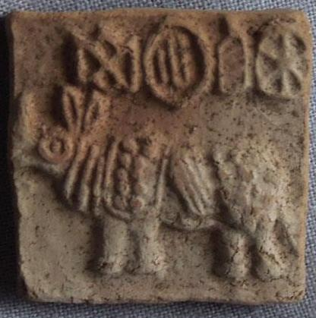

**PK119.5, no. 2.** Terracotta stamp seal with a male figure seated frontally, with legs in ritual meditating posture. This figure is possibly a proto-Shiva, but he has neither headdress nor arm bracelets that usually characterize frontally facing deities. Other similarly seated figures are from Mohenjo-daro, so this may originate from there too. An Indus inscription of 5 symbols is above the seated individual. The reverse shows a structured surface.

Height 2.8 cm. Maximum Width 2.8 cm. Maximum Depth 0.5 cm.

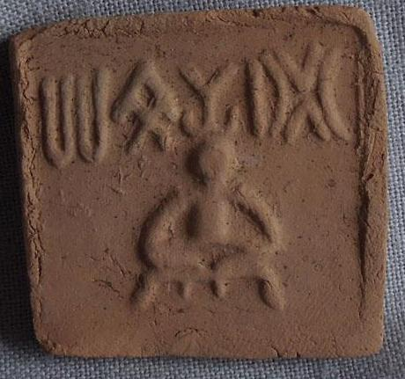

**PK119.5, no. 3.** Terracotta stamp seal of a ceremonial scene**.** In the upper right is a worshipper with both hands raised in supplication before a deity in a forest, which is indicated by an anthropomorphic figure between two conjoined trees. Below this scene is an Indus inscription of a single symbol. A sacred animal appears in the upper left with an Indus inscription of two symbols above. Below are seven worshippers. The first and seventh figures have no headdresses. Figs. 2-4 and 6 have single-feather headdresses. No. 5 has a conical headdress. This appears to be a processional scene. The reverse shows a structured surface.

The seven figures in the lower register are referred to in Rig Veda X 72,8, X 82.2 as the seven sons of Aditi, who are equated with the seven stars of Ursa Major, the Great Bear (*rksa*). *Rksa* is homophonous with *rsi*, seer, and the seven figures of the Edakkal petroglyph may be their origin. Aditi’s eighth son is Martanda, mankind, and equated to the Sun, because he is reborn periodically. He may be the figure in the forest symbolized by the conjoined trees (Richter-Ushanas 2007: 83).. To the right of the right-hand tree is a pyre with suggests that the forest is about to burned by Agni, the god of fire. I this is correct then Martanda is about to be consumed and reborn as the feathered worshipping figure beside the left-hand tree will witness.

## Height 2.9 cm. Maximum Width 3.0 cm. Maximum Depth 0.5 cm.

.

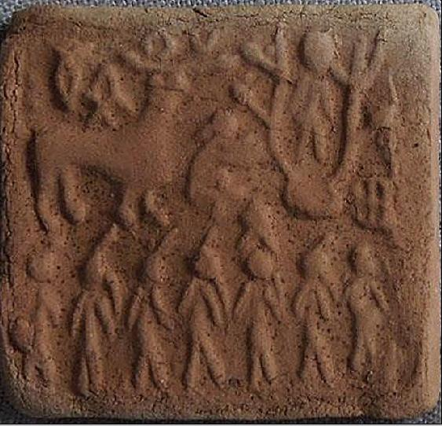

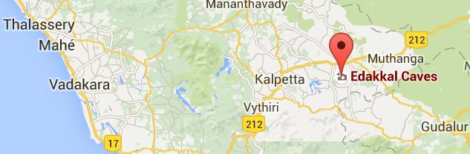

**Edakkal Caves, from** [**https://www.google.com/maps/place/Edakkal+Caves/**](https://www.google.com/maps/place/Edakkal+Caves/)**.**

A similar petroglyph of a processional scene ca. 6,000 –7000 BCE was discovered by E. O. Tillner in 1981 (in one of the three natural Edakkal **Caves**  ([11°37′28.81″N 76°14′8.88″E](https://tools.wmflabs.org/geohack/geohack.php?pagename=Edakkal_Caves&params=11_37_28.81_N_76_14_8.88_E_type:landmark_region:IN), 1,200 m asl at Ambukutty Mala, along an ancient trade route connecting Mysore’s mountains to the ports of the Malabar coast in the Wayanad district of Kerala in the Western Ghats. “Kerala’s” etymology may derive from *cherive-alam* ("declivity of a hill or a mountain slope" in Classical Tamil), which would accord with the name of Edakkal, which also means a “declivity of a hill.” "*Keralam*" may stem also from the Classical Tamil or *chera ala*m ("Land of the Cheras") who would have been the people responsible for the petroglyphs of Edakkal.

The earliest Sanskrit text to mention Kerala is the *Aitareya Aranyaka* of the *Rigveda*, found in the first six chapters of the *Taittiriya Aranyaka* possibly dating to as early as 1700 BCE (Oberlies 1999: 155-158). The first two chapters are part of the *astau kathakani* (the "8 Kathaka sections"),which are a south Indian recension not native to the tradition of the Taittiriya shakha and deal with varieties of the Agnicayana ritual (Keith 1914: xxviii). The Agnicayana ritual (ca. 1000 BCE) exemplifies the Rig Veda construction of a fire altar (agni) as a gateway to pour sacrifices into over a twelve day period where it is believed to be efficacious for personal gain including health (Rodrigues 64). Along with this health theme is Ashoka’s (274–237 BCE) Rock Edict 2 in which “*Keralaputra*” is named (derived from *Cherathala makan*, which refers to the local ruler as "son of the *Chera*[*s*]") which further substantiates that the earliest recorded inhabitants in the vicinity of the Edakkal caves were named “*Cheras*” an identity preserved some three thousand years down to the edicts of Ashoka in the third century BCE.

Rock Edict 2: Everywhere [2] within Beloved-of-the-Gods, King Piyadasi's domain, and among the people beyond the borders, the Cholas, the Pandyas, the Satiyaputras, the **Keralaputras**, as far as Tamraparni and where the Greek king Antiochos rules, and among the kings who are neighbors of Antiochos,[3] everywhere has **Beloved-of-the-Gods, King Piyadasi, made provision for two types of medical treatment: medical treatment for humans and medical treatment for animals. Wherever medical herbs suitable for humans or animals are not available, I have had them imported and grown. Wherever medical roots or fruits are not available I have had them imported and grown. Along roads I have had wells dug and trees planted for the benefit of humans and animals.[4] (**Dhammika 1993)

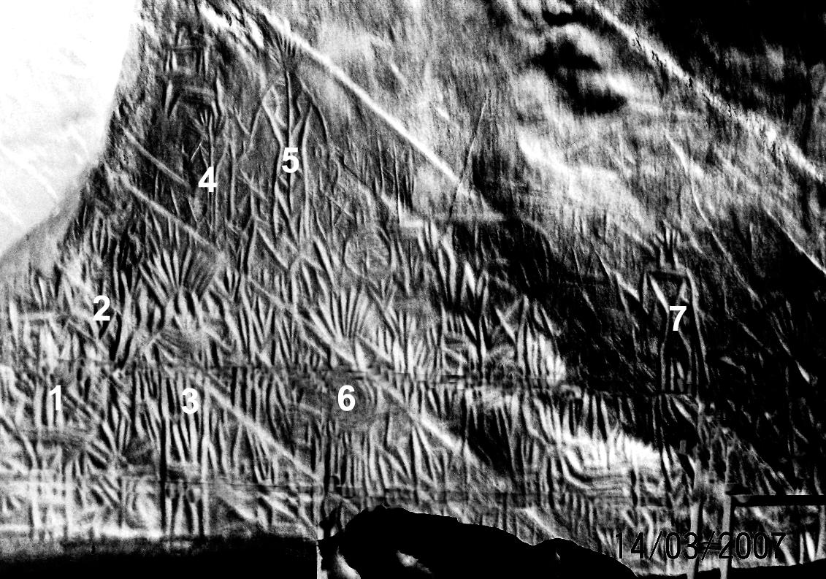

Edakkal Cave petroglyph of the processional discovered by E. O. Tillner (1981-1982).

The Edakkal Cave petroglyph may reflect this health theme in its processional of feathered attendants which accords with the feathered attendants in the processionals on the Indus steatite seal 2430 and Atlantika “**PK119.5, no. 3.** Terracotta stamp seal of a ceremonial scene”. Therefore, it is possible that the scene depicted in the Atlantika Indus terracotta stamp seal and the Indus steatite seal of 2430 may derive from the Edakkal petroglyph processional ca 6,000 to 7,000 BCE. This suggests that the theme of the Indus steatite seal 2430 and Atlantika “**PK119.5, no. 3** originated in a Neolithic time horizon. Further, the *Aitareya Aranyaka* of the *Rigveda* detail the Agnicayana ritual (ca. 1000 BCE) for effecting personal health and that the Ashoka Rock Edict no. 2 (third century BCE) also deals with health of humans and animals associated with medicinal herbs and also may reflect this ancient ceremonial.

References

# Dhammika, Ven. S. 1993. The Edicts of King Ashoka. The Wheel Publication No. 386/387. Kandy: Sri Lanka: Buddhist Publication Society.

# Keith, Arthur Berriedale. 1914. *The Veda of the Black Yajus school, entitled Taittiriya sanhita*. Harvard oriental series, v. 18-19. Cambridge, Mass., Harvard University Press.

# Oberlies, Thomas. 1999. *Die Religion des Rigveda / Tl. 2, Kompositionsanalyse der Soma-hymnen des Rigveda*. Publications of the De Nobili Research Library, vol. 27. Wien : Sammlung De Nobili.

Richter-Ushanas, Egbert. 2007. *The Message of the Indus Seals and Tablets as Preserved in th Rg-Veda and the Adjacent Traditions. A contribution to the decoding of the Indus Script and to the anthropology of the Orient.* 2nd ed. Worpswede, Germany: The Author.

Tillner, E. O. 1981-1982. “Die Edekal Hoehle im Ambukuthy Crack am Battery Rock”. *Jahrbuch der Gesellschaft für Vergleichende Felsbildforschung*. Graz: Ges.

# 

**PK119.5, no. 4.** Terracotta stamp seal with a cow drinking from a trough and an Indus inscription of four symbols above. The reverse shows a structured surface.

Height 3.0 cm. Maximum Width 3.2 cm. Maximum Depth 0.5 cm.

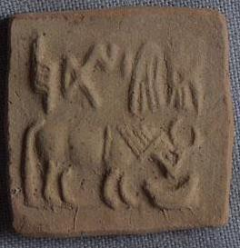

**PK119.5, no. 5.** Terracotta stamp seal of an elephant with a caparison facing right and an Indus inscription of eight symbols above. The reverse shows a structured surface.

# Height 2.6 cm. Maximum Width 2.5 cm. Maximum Depth 0.4

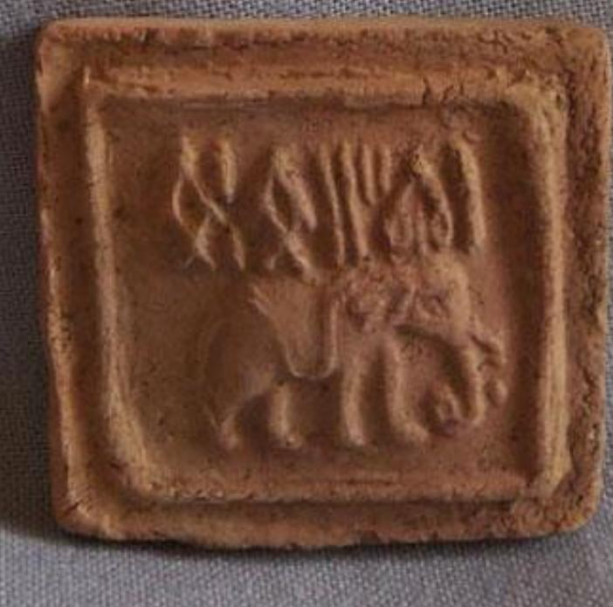

**PK119.5, no. 6.** Terracotta stamp seal with a double-prowed ship with a cabin on deck and an Indus inscription of five symbols above. The reverse shows a structured surface.

**Height: ;Width: ;Length: ;Weight: .**

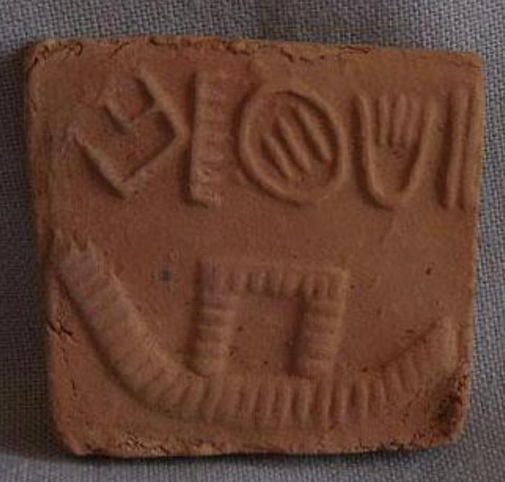

**PK119.5, no. 7.** Terracotta stamp seal with a *Bos Indicus* facing right and an Indus inscription of four symbols above. The reverse shows a structured surface.

Height 2.6 cm. Maximum Width 2.8 cm. Maximum Depth 0.4 cm. **.**

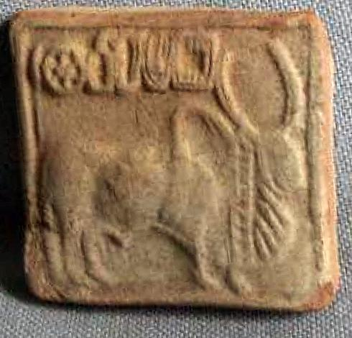

**PK119.5, no. 8.** Terracotta stamp seal with an unidentified animal standing to the right before an anthropomorph with an Indus inscription of six symbols above. The reverse shows a structured surface.

**Height: ;Width: ;Length: ;Weight: .**

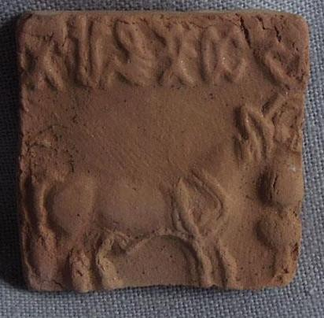

**PK119.5, no. 9.** Steatite seal engraved with unicorn standing before a ritual offering stand and an Indus inscription of six symbols above. The reverse has a carved, protruding suspension loop. The lower left of the seal was broken in antiquity and reaffixed.

**Height: ;Width: ;Length: ;Weight: . Auction prices for a similar seal ca. 4K in 2016.**

**IMAGE NOT SHOWN**

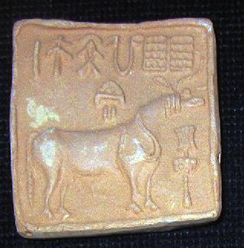

**PK119.5, no. 10.** Terracotta stamp seal with an unidentified animal standing to the right before a ritual offering stand and an Indus inscription of six symbols above.

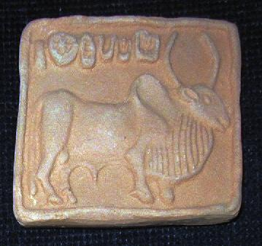

**PK119.5, no. 11.** Terracotta stamp seal

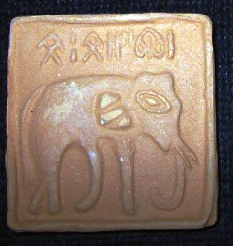

**PK119.5, no. 12.** Terracotta stamp seal

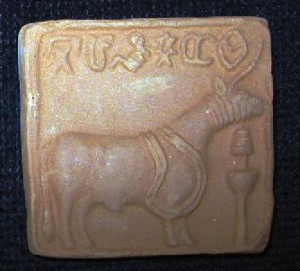

**PK119.5, no. 13.** Terracotta stamp seal

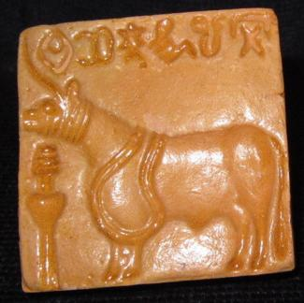

**PK119.5, no. 14.** Terracotta stamp seal

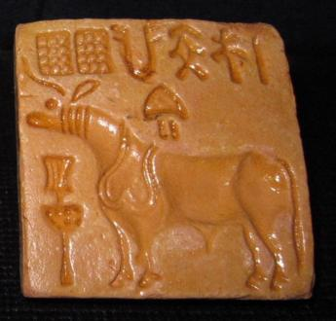

**PK119.5, no. 15.** Terracotta stamp seal

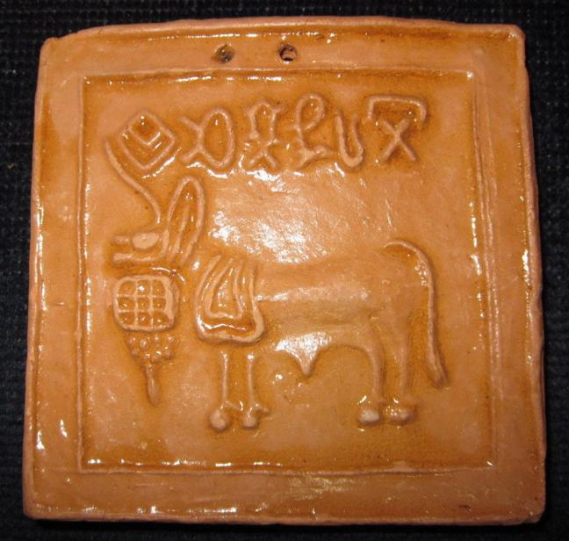

**PK119.5, no. 16.** Terracotta stamp seal

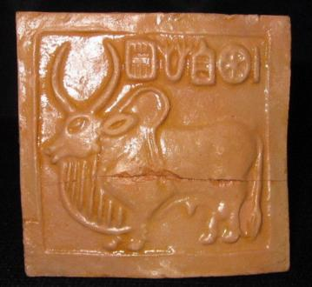

**PK119.5, no. 17.** Terracotta stamp seal

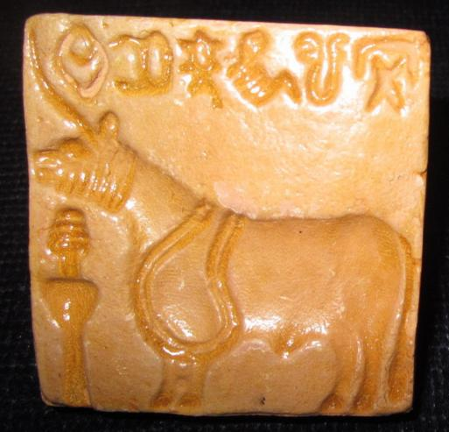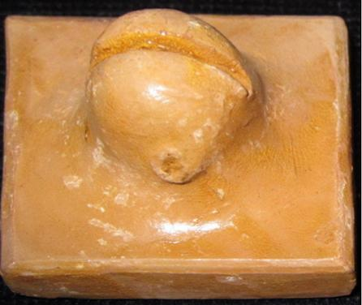

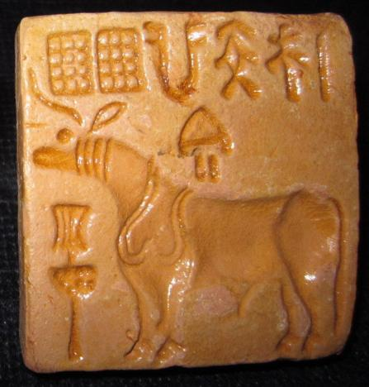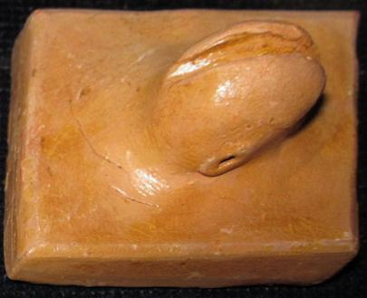

**PK119.5, no. 18.** Terracotta stamp seal

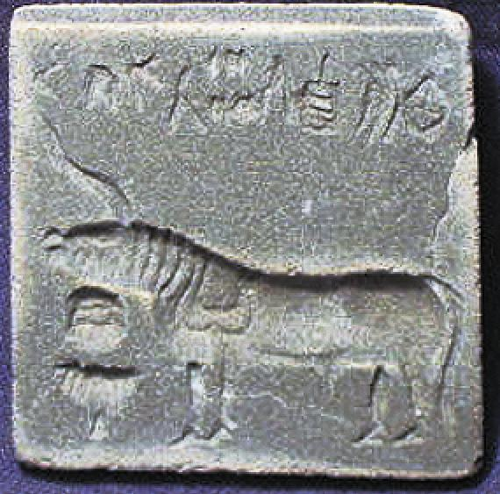

**PK119.5, no. 19. Steatite stamp.** Unicorn, ritual offering stand, 8 symbols above. 4cm. x 4cm.

**7. References:**

Meadow, R.H. and J.M. Kenoyer. 2001. “Recent discoveries and highlights from excavations at Harappa: 1998-2000” *INDO-KOKO-KENKYU* [Indian Archaeological Studies] 22: 19-36.

**8. Provenances or Sources:**

**9. Hidden Field: [Date Purchased, Actual Cost, Recent Auction Price for Similar Item]**

**PK119.5, no. 9. Auction prices for such a seal ca. 4K in 2016.**